**1.INTRODUCTION**

**Overview**

Since the inception of the theory and idea of development, the common feature that emerged in different point of time is the developmental gap that emerged in different parts of the world and also among various parts of a country in a particular time period. This disparity in development, like many other indicators, has also been reflected in India. Traditional development theories believed that agriculture, industrialisation, urbanisation, are significant ingredients of growth, and, ultimately important prerequisites for achieving development. Within the economy itself, the status of growth of a state can be judged through its performance in agricultural and industrial production, performance of service sector and urbanisation, and their impact through their contribution in income and employment generation at the national level. Thus, house price behaviour may also reflect some short of developmental status of the households of a country. Keeping in view the above fact of rapid urbanisation and regional disparities, it is not unexpected that it may lead to some sort of differences in regional house prices, where housing and real estate are considered as major sources of physical and financial asset. This also leads to the differences in the dynamics of house price determination. It simply means that there might be shift of house prices in cities from average, in the country, depending upon its economic status. For instance, average house prices in the poorer provinces might be lower than the national average. Similarly, for richer states, the urban house prices, on average might be higher than the national average.

The Times of India (2012) report indicates that housing prices in India witnessed the steepest rise in the world in the last 10 years since 2001. “House prices in India have increased by 284% in real terms, after allowing for inflation — equivalent to an average annual rise of 14%. The upward movement could be due, significantly, to, rapid urbanisation, increase in population, migration from rural areas as a result of unsatisfactory performance in agriculture and expectation for better livelihood, in terms of greater earning possibilities in urban areas. Only couple of cities registered price decline in the last quarter of 2011. Hence, this paper focuses upon residential property prices in metropolitan cities in India, more specifically, on the study of fifteen metropolitan cities located at different parts of the country consisting Delhi, Mumbai, Bengaluru, Kolkata, Chennai, Jaipur, Lucknow, Hyderabad, Pune, Surat, Ahmedabad, Patna, Faridabad, Kochi and Bhopal. Due to their locations, the cities are having regional characteristics. Against this background, the basic question that arises is whether these fifteen metropolitan cities act as a single market or they work separately as segmented independent metropolitan housing markets within the country. In other words, does the Law of One Price (LOOP) hold true in the housing market of the fifteen metropolitan cities of India? Although a number of studies have been conducted for some countries to determine the convergence of house prices in the respective regions4 , to the best of our knowledge, no such study has been conducted for India.

**PURPOSE**

Prediction house prices are expected to help people who plan to buy a house so they can know the price range in the future, then they can plan their finance well. In addition, house price predictions are also beneficial for property investors to know the trend of housing prices in a certain location

**2 .Problem Definition & Design Thinking**

**Empathy Map**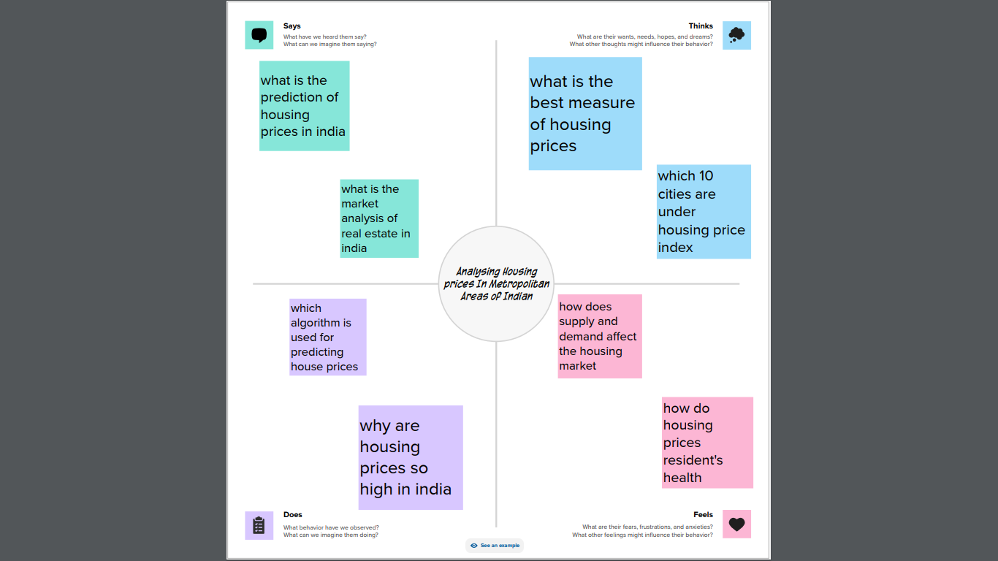

**IDEATION & BRAINSTORMING MAP**



**RESULT**

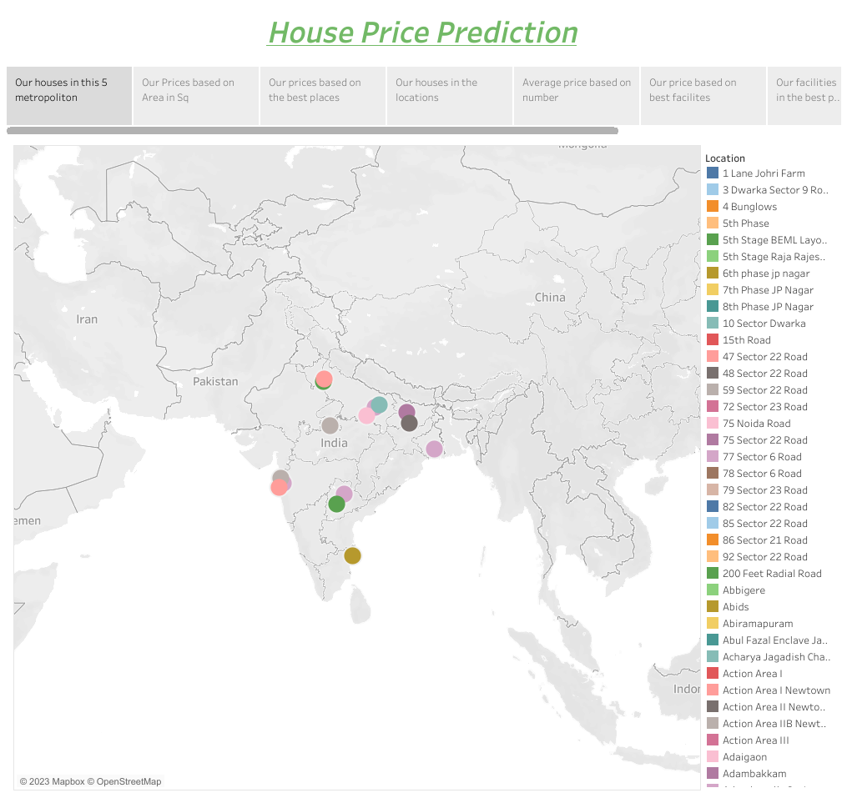

**4. ADVANTAGES & DISADVANTAGES**

**ADVANTAGES**

Modeling House Price Prediction using Regression Analysis and House price prediction can help the developer determine the selling price of a house and can help the customer to arrange the right time to purchase a house. There are three factors that influence the price of a house which include physical conditions, concept and location

**DISADVANTAGES**

The disadvantages of owning a home mostly fall into the category of permanence, with a dash of financial uncertainty. Buying a new house costs money, and a lot of that money comes out of your pocket at the time of the purchase. Later, there are no guarantees that home prices will rise

**5.APPLICATIONS**

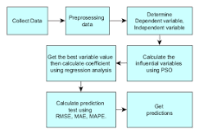

House price prediction can help the developer determine the selling price of a house and can help the customer to arrange the right time to purchase a house. There are three factors that influence the price of a house which include physical conditions, concept and location.

**6.CONCLUSION**

This paper analyzes whether the Law of One Price (LOOP) holds in the housing

market of fifteen metropolitan areas in India, namely Delhi, Mumbai, Bengaluru,

Kolkata, Chennai, Jaipur, Lucknow, Hyderabad, Pune, Surat, Ahmedabad, Patna,

Faridabad, Kochi and Bhopal. We test the existence of LOOP using the Im, Pesaran

and Shin (2003) panel unit root test based on quarterly data on residential property

prices covering the period of 2007Q1 to 2011Q4 of the Indian housing market. Based

on the criterion of price convergence, house prices in the 15 metropolitan cities do not

converge to the LOOP. This implies that the housing markets in the different areas

operate as segmented independent local markets. Therefore, house prices in one

location in India cannot impose a competitive constraint on house prices in other

location, and as such a home owner can freely set the price of his house

**7.FUTURE SCOPE**

"India's real estate sector is expected to expand to USD 5.8 trillion or USD 5,833 billion by 2047. This estimated real estate output value will contribute 15.5 per cent to the total economic output in 2047 from an existing share of 7.3 per cent," Naredco-Knight Frank said in a statement

